**UNITED METHODIST CHURCH OF CADILLAC**

**REV. KAREN SORDEN**

**SUNDAY, APRIL 27, 2025**

**PRELUDE**

**BRINGING IN THE LIGHT OF CHRIST**

**WELCOME AND ANNOUNCEMENTS**

**WE ENTER INTO GOD’S DIVINE PRESENCE**

**\*CALL TO WORSHIP (congregation in bold)**

We are people of the twenty-first century, far removed from the Upper Room.

**“Blessed are those who have not seen and yet have come to believe.”**

We have put away the festive trumpets, the fancy clothes, the chocolate bunnies

of Easter Sunday. Must the message of Easter be put away for another year?

**“Blessed are those who have not seen and yet have come to believe.”**

We still seek the One who offers victory over death, whose love conquers evil.

**“Blessed are those who have not seen and yet have come to believe.”**

We gather to worship the risen Christ who offers us new life.

**“Blessed are those who have not seen and yet have come to believe.”**

**\*OPENING HYMN UMH 304**

**“Easter People, Raise Your Voices”**

**\*UNISON OPENING PRAYER**

**Lord Jesus Christ, the light of your love shines on, illuminating the places where you are present. As the bewildered disciples pondered the stories of your appearance, you penetrated the darkness of their fear and doubt with your word of peace. You showed them the appalling marks of evil pierced on your hands and feet. You opened their minds to understand why you had to die to defeat such evil and death. Increase our understanding and open our minds and hearts to receive you, Lord. Speak your word of peace to us and let your love shine on any dark areas in our lives. May this worship which we offer in your name be a worthy response to your love and your sacrifice for us. Amen.**

**WE CONFESS OUR SINS TO GOD**

**CALL TO CONFESSION**

**UNISON PRAYER OF CONFESSION**

**God of empty tombs and emptier people, when we hesitate to speak of your hope, forgive us and give us a voice. When we find it difficult to love one another, forgive us and give us fresh compassion. When we want to stand with the high and mighty, forgive us and seat us next to the poor and oppressed. When we stay locked behind our fears and doubts, forgive us and send us out to share your grace. When we cannot believe your Word of new life, forgive us and fill us with your joy. Amen.**

**A MOMENT FOR SILENT CONFESSION**

**ASSURANCE OF FORGIVENESS (congregation in bold)**

Christ comes into every shadowed corner of our lives with the light of Easter.

Christ comes into the locked rooms of our faults and gifts us with grace and hope. **Christ comes to fill us with peace so we may proclaim the good news of mercy and forgiveness for all. Thanks be to God! Amen.**

**WE HEAR GOD’S WORD PROCLAIMED**

**SPECIAL MUSIC Gospel Guitar Band**

**SCRIPTURE READING**  **John 20: 19-31**

**SERMON**  **Pastor Karen Sorden**

**“Finding God in the Questions”**

**WE RESPOND IN JOYFUL SERVICE**

**\*HYMN OF RESPONSE UMH 308**

**“Thine Be the Glory”**

**MINISTRY OF PRAYER**

**Sharing our Joys and Concerns**

**Pastoral Prayer**

**The Lord’s Prayer**

**Our Father, who art in heaven, hallowed be thy name. Thy kingdom come, thy will be done on earth as it is in heaven. Give us this day our daily bread. And forgive us our trespasses, as we forgive those who trespass against us. And lead us not into temptation, but deliver us from evil. For thine is the kingdom, and the power, and the glory forever. Amen.**

**OFFERING OUR TITHES AND GIFTS TO GOD**

**Offertory**

**\*Doxology**

**\*Unison Prayer of Dedication**

**Generous and surprising God, when we thought that death had claimed your only Son, you amazed us with the resurrection. Surprise us again with your ability to turn these humble offerings into gifts that will transform the world through our witness to your love. We lay our very lives at your feet, O God, knowing that you will use us to proclaim and embody the gospel. Amen**

**WE GO FORTH TO SERVE**

**\*AFFIRMATION OF FATIH – “I Believe” See Insert**

**\*CLOSING HYMN UMH 364**

**“Because He Lives”**

**\*BENEDICTION**

**\*POSTLUDE**

**UNITED METHODIST CHURCH**

**OF CADILLAC**

**April 27, 2025**

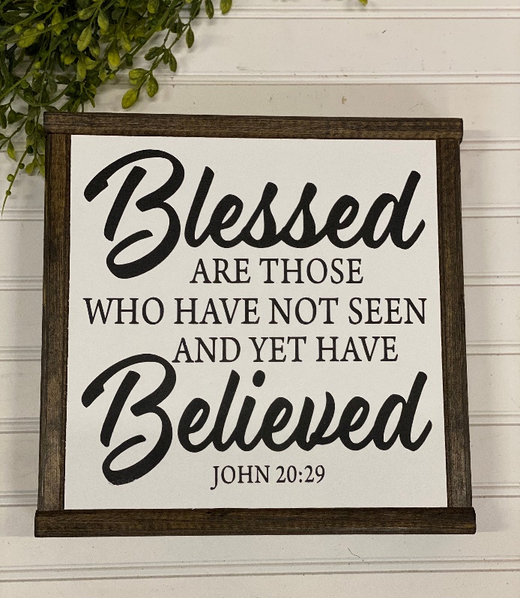

***Our Mission***

*To Lead Everyone in Relationship with Christ.*

***Our Vision***

*Bringing people to Christ; developing personal*

*growth in Christ; putting Christ into action.*

**\*AFFIRMATION OF FAITH – “I Believe”**

**In spite of many unanswered questions, I believe.**

**I believe in the living God, the joy of the universe,**

**who is the pulse and purpose of all things seen and unseen,**

**who from the dust of earth calls up living beings to be**

**children of eternity, who through countless ages has**

**provided for us many liberators and tirelessly seeks to**

**bring victory out of defeat and life out of decay.**

**I believe in Jesus the Christ, God’s true Son, who is bone of our bone and flesh of our flesh, who took upon himself the healing of the human race, who bearing the burden of our sins went to Golgotha carrying his cross, who was betrayed, crucified, dead and buried in a borrowed tomb, who on the third day was found to be gloriously alive, meeting with those who trust him and serve him to the end of the world.**

**I believe in the Holy Spirit of God, within and among all who cherish Christ and his way, who brings hope out of despair, love out of apathy, and joy out of sorrow, who unceasingly regenerates and reforms the church that it may always be the contemporary body of the risen Christ, loving the world through prayer, word, and deed.**

**I believe that even I am caught up in the resurgent life of Christ Jesus, and that nothing in life or death can separate me from his love and joy.**

**In spite of unanswered questions, yes, I believe. Amen!**

**\*AFFIRMATION OF FAITH – “I Believe”**

**In spite of many unanswered questions, I believe.**

**I believe in the living God, the joy of the universe,**

**who is the pulse and purpose of all things seen and unseen,**

**who from the dust of earth calls up living beings to be**

**children of eternity, who through countless ages has**

**provided for us many liberators and tirelessly seeks to**

**bring victory out of defeat and life out of decay.**

**I believe in Jesus the Christ, God’s true Son, who is bone of our bone and flesh of our flesh, who took upon himself the healing of the human race, who bearing the burden of our sins went to Golgotha carrying his cross, who was betrayed, crucified, dead and buried in a borrowed tomb, who on the third day was found to be gloriously alive, meeting with those who trust him and serve him to the end of the world.**

**I believe in the Holy Spirit of God, within and among all who cherish Christ and his way, who brings hope out of despair, love out of apathy, and joy out of sorrow, who unceasingly regenerates and reforms the church that it may always be the contemporary body of the risen Christ, loving the world through prayer, word, and deed.**

**I believe that even I am caught up in the resurgent life of Christ Jesus, and that nothing in life or death can separate me from his love and joy.**

**In spite of unanswered questions, yes, I believe. Amen!**