
Upcoming Birthdays
October 29 – Terry Tatarchuk
October 31 – Laurie Kinney
November 1 – Kathy VanHulst

Pastor Earl Detwiler
Email: broffermoon@gmail.com
Phone: 785.213.1886
Prayer Requests (email): umccadillac@gmail.com
Church Website: www.cadillacumc.org
Church Email: umccadillac@gmail.com
Church Mailing Address: PO Box 37, Cadillac, MI 49601
Phone: (231) 775.5362
Office Hours: Monday - Thursday 10:00 a.m. - 4:00 p.m.
Pastor Earl’s Office Hours: Monday – Thursday 9:30 am – 1:00 pm
Closed on Fridays

Volunteer Ministry for Sunday, November 2, 2025
Organist/Pianist: Skip Pluger
Liturgist: Laurie Kinney
Ushers/Greeters: Jack Davis, Dee Brinks, MJ VanderHart
3 dozen cookies (each) for Coffee Hour: Lark Miller, Judy Davis
_____________________________________________________________
CHURCH STAFF
Pastor: Rev. Earl Detwiler
Office Manager: Diane Coon
Treasurer: Sara Austin
Choir Director: Reg Klubeck
Organists: Ruth Boonzaaijer, Cora McLean, Skip Pluger,
Dr. Glenn Verbrugge
Nursery: Diana VanAntwerp
What’s Happening at Church This Week………
Sunday, October 26
Blood Pressure Clinic before & after Service
10:30 a.m. – Worship Service

Monday, October 27
3:00 p.m. – Prayer Group in Wesley Room
7:00 p.m. – Boy Scout Troop #125 in Fellowship Hall
Tuesday, October 28
3:30 p.m. – Old & New Testament Study in Fellowship Hall
5:00 p.m. – Guitar Practice in Corbin Room
Wednesday, October 29
10:30 a.m. – 12:30 p.m. – Weight Loss Group in Corbin Room
4:00 p.m. – Choir Practice
5:00 – 6:30 p.m. – Trunk or Treat in Parking Lot (replaces Game Night)
7:00 p.m. – Alcoholics Anonymous in Corbin Room
Thursday, October 30
3:00 – 5:00 p.m. – Patriot Choir in Corbin Room
5:30 – 7:30 p.m. – Jam & Bread in Education Wing & Corbin Room
Friday, October 31
Church Carpet Cleaned
8:00 p.m. – Alcoholics Anonymous in Fellowship Hall

Sunday, November 2 – All Saints Sunday
10:30 a.m. – Worship Service w/Holy Communion

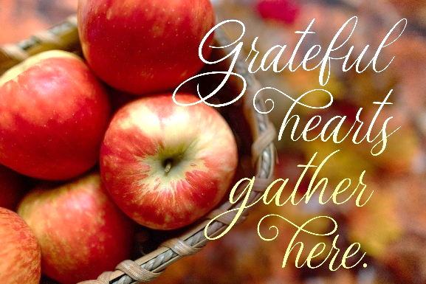

Our Loose Plate Offering for November will go to help Meals on Wheels, an organization that improves the health and well-being of homebound seniors by providing vital nutrition, compassionate visits, and safety checks enabling seniors to live nourished lives with independence and dignity. If you wish to write a check, please put on the memo line: November Loose Plate. Thank you for your consistent generosity.

I want to thank my church family for your kind and generous love gift for my retirement. I appreciate your thoughtfulness and can feel your love. The first thing I had to do in my retirement was have a new water heater installed, so your gift was quite timely! I hope everyone is doing well and continue to wish you all God's blessings. Pastor Karen

Save the Date!! The Cadillac Community Jazz Group will be performing a Christmas concert here on Sunday, November 23 at 3:00 p.m. This is the Sunday before Thanksgiving so this event is sure to get you in the Christmas spirit for the holidays! Come and enjoy the music of this talented group of musicians!

This year for our Thanksgiving Offering we are once again filling Blessing Bags for the Salvation Army. We hope to have the bags here for you by the end of October.

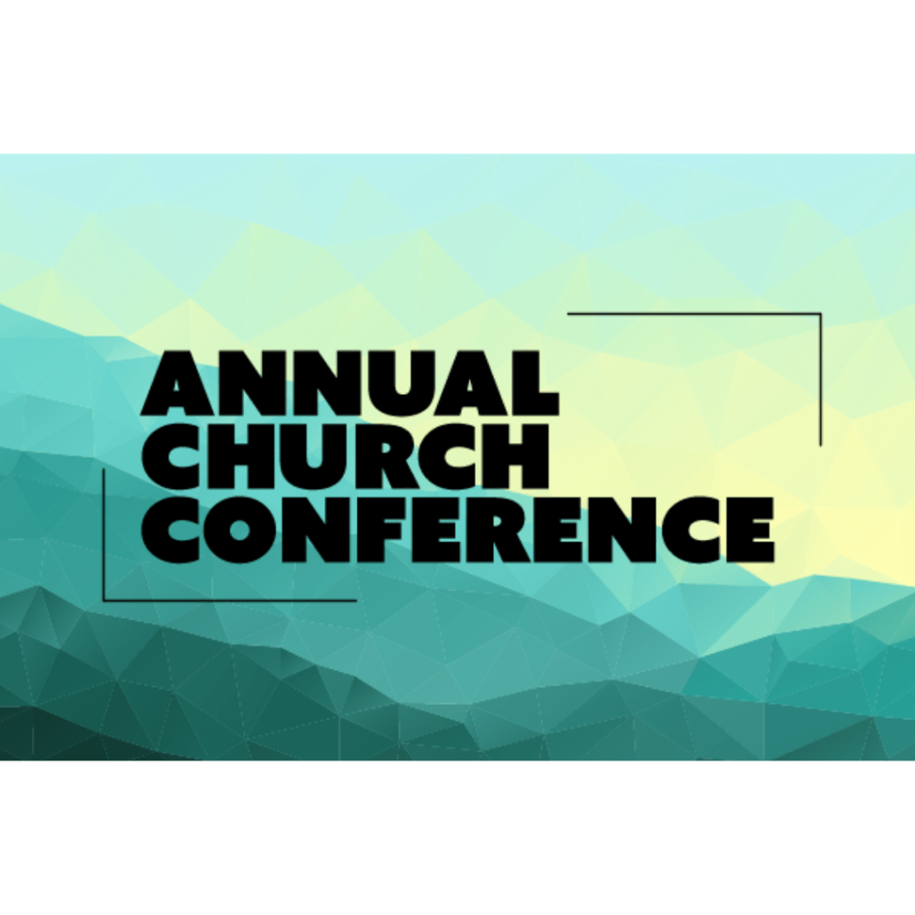

Our Annual Church Conference will take place here on
Sunday, November 9
at 2:00 p.m.
The church family is encouraged to attend.
Today’s Worship Ministry…………….
Organist/Pianist: Ruth Boonzaaijer
Liturgist: Deb DeBruyn
Greeters/Ushers: Jack Davis, Margaret Himes, Kay Hinkston,
Bob Newland
3 dozen cookies (each) for Coffee Hour: Kay Hinkston, Mary Buehler


Flowers On the Altar Are Given by
Dan & Laurie Kinney in Honor of
Laurie’s Birthday on October 31

Blood Pressure Clinic TODAY Jane Payne will be here to take your blood pressure before or after service and answer any medical questions you may have. Please take advantage of this great service Jane offers.

The November Volunteer Ministry Sign-Up Sheet for bringing cookies for Coffee Hour is on the food table in Fellowship Hall. Thank you to those that have already signed up. We still need (2) each for November 16, 23 and 30. Remember, volunteers are expected to set up and clean up afterwards. If you have never volunteered for this, please consider doing so.


Your tithes and offerings may be sent directly to the church at P.O. Box 37, Cadillac, MI 49601. If you wish to give online, you may scan the QR code to be connected to "Servant Keeper Online Giving." We thank you for your generosity.

